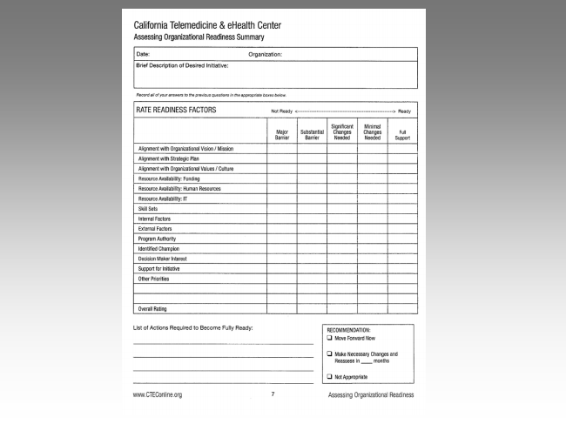
California Telemedicine & eHealth Center
Assessing Organizational Readiness Summary
Date: Organization:
Brief Description oi Desired Initiative:
Not Ready c > Heady
Significant Minimal Majm Substantial Changes Changes Full Barrier Barrier Needed Needed Support
Alignment wilh Dtganizatiunal Vision I Mission
Alignment with Sirategic Plan
Aiignmenl with Organizational Values 1' Culture
Resource Avaiiabilily: Funding
“BSOLITCB HVBIIEDIIIIYI Resource Availability: Human Resources 1
RCSGUICB lY: IT
Skill Sets
{nternal Factors
External Factors
Program Authority
Identified Champion
Decision Maker Interest
Support for Initiative
Other Priorities
Overall Rating
List of Actions Required to Become Fullyr Ready: RECOMMENDATION:
U Move Forward Now
El Make Necessary Changes and Heassess in months
Cl NotAppropriate
vawaCTEConlineorg 1' Assessing Organizational Readiness

